Dear Student,
You have to solve the given problem statement by yourself. First read it carefully and try to solve it. There is no need to copy it from anywhere or to solve it in the group. Try to analyze yourself. There are no marks for this activity. It is only for your own understanding. In the coming lab, we are going to perform this lab, we will discuss your solution, and try to find out the mistakes.
Lab 01
Problem Statement
Consider the following scenario and identify all objects, their attributes and behaviors.
In Virtual University bookshop, the handouts of all courses are provided at reasonable price. The handouts are made in accordance with the video lectures recorded by famous professors. It is a step to facilitate students to easily digest the course contents.
Solution:
Objects | Attributes (characteristics) | Behaviors (operations)
Bookshop | Name  Address (location)  Phone number  list of books | Set Order  Get Order  Confirm Order  Deliver order  Update Inventory (update order)  Payment receive/ collect
Handout | Title  No. of topics /chapters  Page number  Author  Publisher  Creation date  Modify date  Edition | Upload  Download  Edit  Print  Read  Write  Share  View
Course | Course code  Course name  Course instructor  Credit hour  Total marks  Grading scheme  No. of lectures | Add information  View Information  Edit information  Read  Write
Video Lectures | Video number  Name  Duration  Video quality  Type  Video URL | View / watch  Record  Upload  Download  Stop  Share  Pause  Forward  Reverse  Increase speed  Decrease speed  Increase volume  Decrease volume  playback
Professor | Employee ID  Name  Age  Gender  Qualification  Specialization  Designation  Experience  Salary  No. of taught subjects | Teach  Develop assignment  Solve student’s problems  Develop Quiz  Develop GDB  Prepare Exam  Take Exam  Invigilate  Mark papers  Mark activities  Give grades  Prepare result
Student | Student ID / Roll number  Name  Age  Gender  Student program  Semester  CGPA  No. of courses | Study  Give exam  Attempt activities  Taking lectures  Write notes  Making time table
Course content | No. of topics  Names  Topic number  Topic Description  Composed by  Publish by  Written by | Upload  Edit  View  Share  Write  Download

Lab 02
Problem Statement
In the below diagram, we have two different types of file classes (PDF and Video). You are required to apply the concept of generalization to the given classes and draw a class diagram showing this generalization relationship.
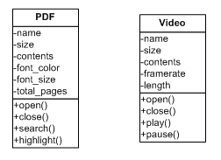
Solution:
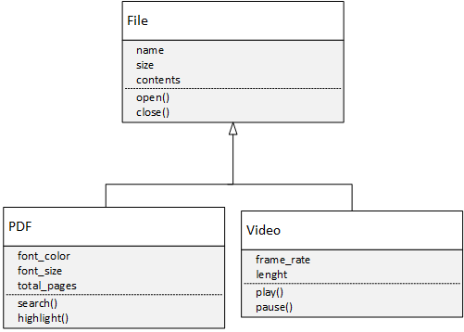
Lab 03
Problem Statement
Write a program which consists of a class named Room having two data members Height and Width, the class should also consist of three constructors i.e., Default constructor, one argument constructor and two arguments constructor.
Sample Output
After running your program, the following screen should display.

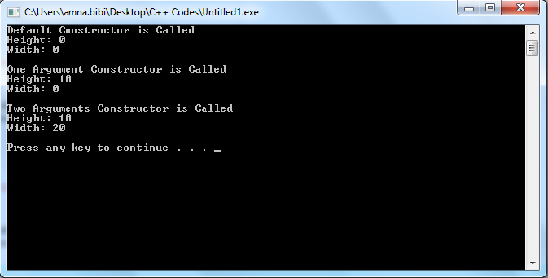
Solution
#include<iostream>
using namespace std;
class Room
{
private: //private variables of type float.
float width;
float height;
public:
Room() //Default Constructor
{
width=0.0; //Default value has been assigned to width
height=0.0; //Default value has been assigned to height
cout<<"Default Constructor is called" <<endl;
cout<<"Height: "<<width<<endl;
cout<<"Width: "<<height<<endl<<endl;
}
Room(float h) //parametrized Constructor (One argument)
{
height=h;
width=0.0;
cout<<"One Argument Constructor is called" <<endl;
cout<<"Height: "<<width<<endl;
cout<<"Width: "<<height<<endl<<endl;
}
Room(float h, float w) //parametrized Constructor (Two argument)
{
height=h;
width=w;
cout<<"Two Argument Constructor is called" <<endl;
cout<<"Height: "<<width<<endl;
cout<<"Width: "<<height<<endl<<endl;
}
};
int main()
{
Room R1, R2(10), R3(20,30);
return 0;
}
Lab 04
Problem Statement
Write C++ coding program which creates a class Pyramid. The class should contain a static data member “Pcount” to store the total number of Pyramid’s objects.
In the main() function, dynamically create three objects of Pyramid class and print the value of “Pcount”. Afterwards, delete any two objects of Pyramid and print the value of “Pcount” again.
Sample Output
Following is a sample output for above scenario:
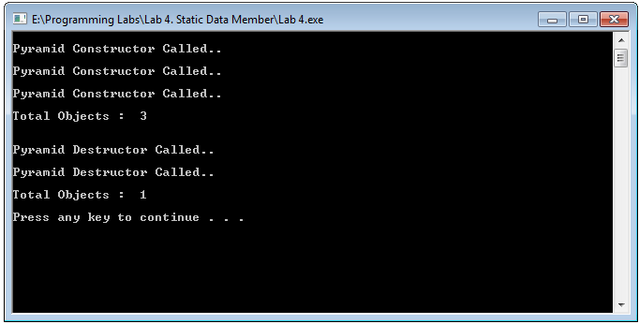

Solution
#include<iostream>
using namespace std;
class Pyramid
{
private: //private static variable of type int
static int Pcount;
public:
static int get_pcount(); //static function get_pcount() and its retrun type is int.
Pyramid(); //Constructor
~Pyramid(); //Destructor
};
main()
{
//This statement is creating an object dynamically and binds its address to a pointer.
//This is the declaration of variable named p1, p2, and p3 which is a pointer to a Pyramid. This pointer object has automatic storage duration. It is then initialized with the result of new Pyramid(). This new keyword creates an p object with dynamic storage duration and then returns a pointer to it.
Pyramid *p1 = new Pyramid;
Pyramid *p2 = new Pyramid;
Pyramid *p3 = new Pyramid;

//prints the number of total objects before deletion.
cout << endl << "Total Objects : " << Pyramid::get_pcount() << endl << endl;

delete p1; //Delete the object p1
delete p2; //Delete the object p2

//prints the number of total objects after deletion.
cout << endl << "Total Objects : " << Pyramid::get_pcount() << endl << endl;

system("pause");
}
int Pyramid::Pcount = 0;

int ::Pyramid::get_pcount() //definition of function get_pcount

{
return Pcount;
}
Pyramid::Pyramid() //definition of constructor
{
cout << endl << "Pyramid Constructor Called.." << endl;
Pcount++;
}
Pyramid::~Pyramid() //definition of destructor
{
cout << endl << "Pyramid Destructor Called.." << endl;
Pcount--;
}

Lab 05
Problem Statement
Write a C++ program which consists of a class named Circle which has one data member radius and setter and getter functions. Overload the + operator for this class.
In main () function, create three objects c1, c2, and c3. Call setter function for objects c1 and c2. The program should be able to execute the following statement;
c3=c1+c2;
Call the getter function for c3.
After running your program, the following screen should display.
Sample Output

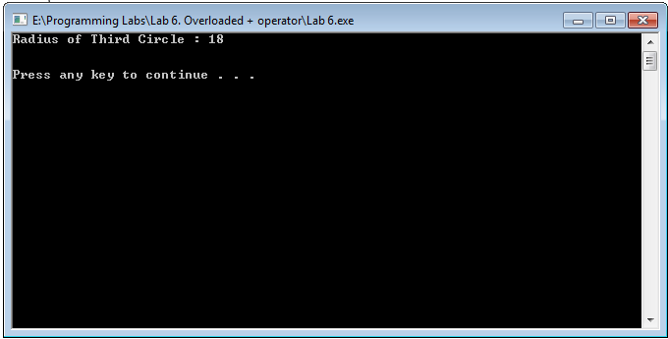

Solution:
#include<iostream>
using namespace std;

class Circle{
private:
double radius; // variable

public:
void setRadius(double r)// setter
{
radius= r;
}
double getRadius() // getter
{
return radius;
}

Circle operator+(const Circle& c)
{
Circle cir;
cir.radius=this->radius+c.radius;
return cir;
}
};
int main(){
Circle c1, c2,c3;
double r;
c1.setRadius(10.0);
c2.setRadius(20.0);
c3=c1+c2;
r=c3.getRadius();
cout<<"Radius of third Circle:" << r<<endl;
}
Lab 06
Problem Statement
Write a C++ program which consists of a class named Complex which has data members real and imaginary. Overload the stream insertion operator (<<) operator and stream extraction operator (>>) for this class.
In main () function, create an object com1 and take input using stream extraction operator and print output using stream insertion operator
After running your program, the following screen should display.
Sample Output
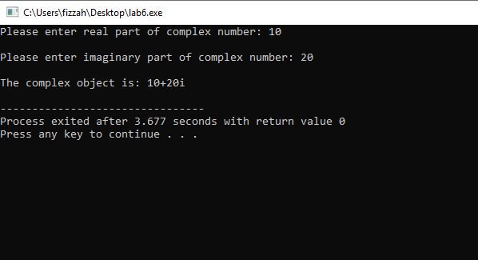
Solution
#include<iostream>
using namespace std;

class Complex
{
private:
int real, imag; //declaration of real and imaginary part of the complex number
public:
Complex(int r = 0, int i =0) //Parametrized Constructor
{
real = r; //assign the value
imag = i; //assign the value
}

//This function is automatically called when “<<” operator is used.
//prototype statement of stream insertion operator
friend ostream & operator << (ostream &outObj, const Complex &com);

//This function is automatically called when “>>” operator is used.
//prototype statement of stream extraction operator
friend istream & operator >> (istream &inObj, Complex &com);
};

ostream & operator << (ostream &outObj, const Complex &com)
{
//this is the code to print the real and imaginary values of complex number
outObj << com.real;
outObj << "+" << com.imag << "i" << endl;
return outObj;
}
istream & operator >> (istream &inObj, Complex &com)
{
//this is the code to read the real and imaginary values of complex number
cout << "Please enter real part of complex number: ";
inObj >> com.real;
cout << "Please enter imaginary part of complex number: ";
inObj >> com.imag;
return inObj;
}
int main()
{
Complex com1; //Creation of object of class Complex
cin >> com1; //This will call the insertion operator function
cout << "The complex object is: ";
cout << com1; //This will call the extraction operator function
return 0;
}

Lab 07
Problem Statement
Write a C++ program which consists of a class named Planet which has no data member and only contains a default constructor. Your program should contain two more classes Inner_Planet and Outer_Planet. Both of these classes should also contain default constructor. Your program should implement the concept of inheritance between “Planet class, Inner_Planet class and Outer_Planet class”.

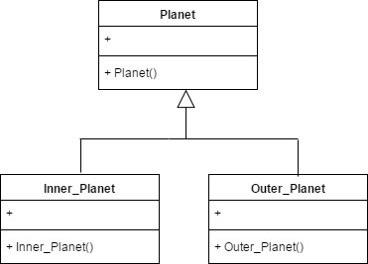
Sequence Diagram
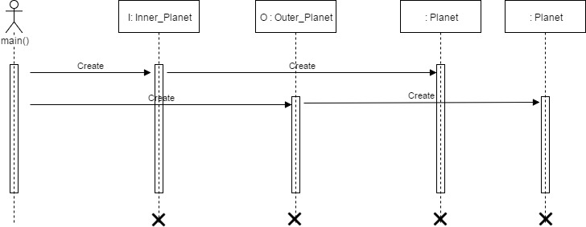
Sample Output
After running your program, the following output screen should display.
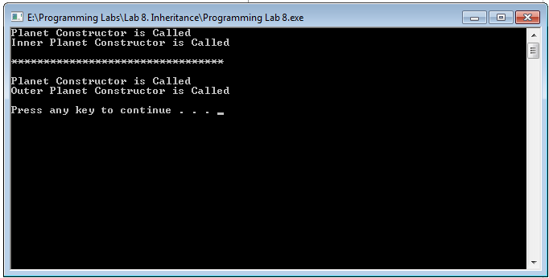
Lab 08
Problem Statement
Write a C++ program which should consist of following four classes.
- Base
- Derived_Private
- Derived_Protected
- Derived_Public
“Base” class should consist of following data members along with following type.
Data member | Access Specifier
secret | private
protect | protected
access | public
Further, “Base” class should contain default constructor to initialize its data members.
Other three classes should be inherited from “Base” class with respect to following type of inheritance.
Class | Inheritance type
Derived_Private | Private
Derived_Protected | Protected
Derived_Public | Public
All three derived classes should contain show() function, which should display the values of secret, protect and access data member of base class. On running this program, your compiler will generate compile time errors. Carefully observe for which type of base class data member, compiler is generating error.
Class Diagram
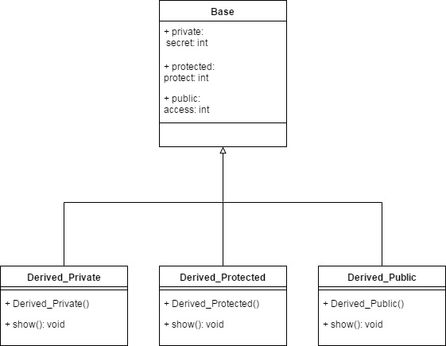
Compilation Results
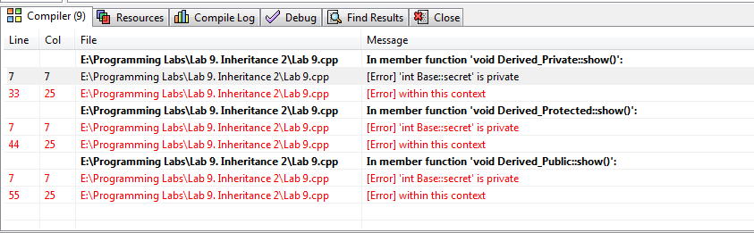

Lab 09
Problem Statement
Class Diagram
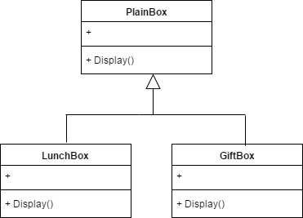
Part (1):
Write C++ program which should contain three classes as follows:
- PlainBox
- LunchBox
- GiftBox
“LunchBox” and “GiftBox” classes should be publically inherited from PlainBox Class.
All three classes should contain Display() function, which should display respective class name.
In main() function, create objects of LunchBox and GiftBox classes dynamically. Static type of these objects should be “PlainBox”. Using object of PlianBox, call Display() function.
Following is a sample output for the above scenario:
Sample Output
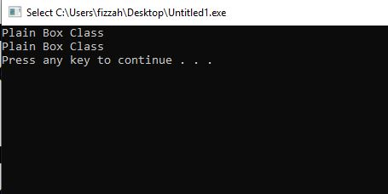

Solution
#include<iostream>
using namespace std;
class plainBox //Base Class
{
public:
void display() //Display Function to display “Plain Box Class”.
{
cout<<"Plain Box Class"<<endl;
}
};

class LunchBox: public plainBox //LunchBox(child) class is inherited from the PlainBox(parent) class.
{
public:
void display() //Display Function to display “Lunch Box Class”.
{
cout<<"Lunch Box Class"<<endl;
}
};
class GiftBox: public plainBox //GiftBox(child) class is inherited from the PlainBox(parent) class.
{
public:
void display() //Display Function to display “Gift Box Class”.
{
cout<<"Gift Box Called"<<endl;
}
};
int main()
{
plainBox *LB= new LunchBox();
//This statement is creating an object dynamically and binds its address to a pointer.
//This is the declaration of variable named LB which is a pointer to a plainBox. This pointer object has automatic storage duration. It is then initialized with the result of new LunchBox(). This new keyword creates an LB object with dynamic storage duration and then returns a pointer to it.
LB->display();
//Calling Display Function.
plainBox *GB= new GiftBox();
//This statement is creating an object dynamically and binds its address to a pointer.
//This is the declaration of variable named GB which is a pointer to a plainBox. This pointer object has automatic storage duration. It is then initialized with the result of new GiftBox(). This new keyword creates an GB object with dynamic storage duration and then returns a pointer to it.
GB->display();
//Calling Display Function.
system("pause");
return 0;
}
Part (2):
Make Display() function of “PlainBox” class virtual and then run the program. Your output should be as follows:
Sample Output

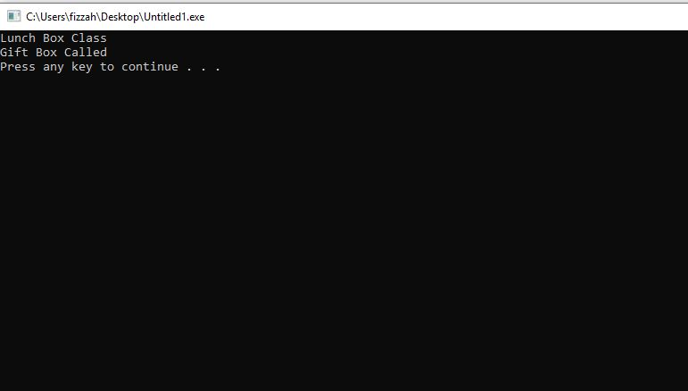
Solution
#include<iostream>
using namespace std;
class plainBox //Base Class
{
public:
virtual void display()
//A virtual function is a member function within the base class that we redefine in a derived class. It is //declared using the virtual keyword. When a class containing virtual function is inherited, the derived //class redefines the virtual function to suit its own needs.
{
cout<<"Plain Box Class"<<endl; //Display Function to display “Plain Box Class”.
}
};
class LunchBox: public plainBox //LunchBox(child) class is inherited from the PlainBox(parent) class.
{
public:
void display()
{
cout<<"Lunch Box Class"<<endl; //Display Function to display “Lunch Box Class”.
}
};
class GiftBox: public plainBox //GiftBox(child) class is inherited from the PlainBox(parent) class.
{
public:
void display()
{
cout<<"Gift Box Called"<<endl; //Display Function to display “Gift Box Class”.
}
};
int main()
{
plainBox *LB= new LunchBox();
//This statement is creating an object dynamically and binds its address to a pointer.
//This is the declaration of variable named LB which is a pointer to a plainBox. This pointer object has automatic storage duration. It is then initialized with the result of new LunchBox(). This new keyword creates an LB object with dynamic storage duration and then returns a pointer to it.
LB->display(); //Calling Display Function.
plainBox *GB= new GiftBox();
//This statement is creating an object dynamically and binds its address to a pointer.
//This is the declaration of variable named GB which is a pointer to a plainBox. This pointer object has automatic storage duration. It is then initialized with the result of new GiftBox(). This new keyword creates an GB object with dynamic storage duration and then returns a pointer to it.
GB->display(); //Calling Display Function.
system("pause");
return 0;
}

Lab 10
Problem Statement
Write C++ code for the following template Bag class.
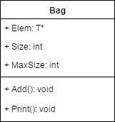
Element is an array which stores the elements present in the bag. Elements can store different types of elements. Size is the number of elements present in Bag and MaxSize hold the max number of element’s a bag can have.
Add method is adding element present in bag into the array Elem and print will print the added elements on screen. Implement partial specialization for the given class to handle pointer to any datatype.
In main create 3 objects one for each integer, character and integer type pointer datatypes. Add at least three elements in each.
Sequence Diagram
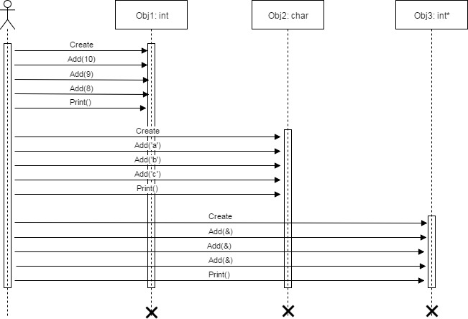
Sample Output
After running your program, the following output screen should display
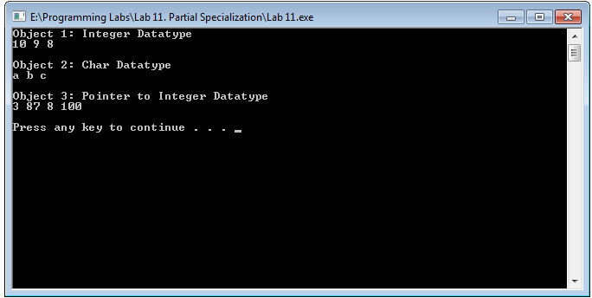
Solution
#include <iostream>
using namespace std;

// Original template collection class.
template <class T> //class template
class Bag
{
T* elem; //private variable of type T
int size; //private variable of type int and size is the number of elements present in Bag
int max_size; //private variable of type int and max_size hold the max number of element’s a bag can have.

public:
Bag() : elem(0), size(0), max_size(1) {} //Initialization list
void add(T t) //Function to add element present in bag into the array Elem
{
T* tmp; // variable of type T
if (size + 1 >= max_size)
//if the elements present in the bag + 1 is greater than the max size of the bag then the following code will run.
{
max_size *= 2; //multiple the max size of bag by 2.
tmp = new T [max_size];
for (int i = 0; i < size; i++)
tmp[i] = elem[i];
tmp[size++] = t;
delete[] elem;

elem = tmp;
}
else
elem[size++] = t;
}

void print() //Function to print the added elements on screen.
{
for (int i = 0; i < size; i++)
cout << elem[i] << " ";
cout << endl;
}
};

// Template partial specialization for pointer types.
// The collection has been modified to check for NULL
// and store types pointed to.
template <class T> class Bag<T*> {
T* elem;
int size;
int max_size;

public:
Bag() : elem(0), size(0), max_size(1) {}
void add(T* t) {
T* tmp;
if (t == NULL) { // Check for NULL
cout << "Null pointer!" << endl;
return;
}

if (size + 1 >= max_size) {
max_size *= 2;
tmp = new T [max_size];
for (int i = 0; i < size; i++)
tmp[i] = elem[i];
tmp[size++] = *t; // Dereference
delete[] elem;
elem = tmp;
}
else
elem[size++] = *t; // Dereference
}

void print() {
for (int i = 0; i < size; i++)
cout << elem[i] << " ";
cout << endl;
}
};

int main()
{
Bag<int> xi;
Bag<char> xc;
Bag<int*> xp; // Uses partial specialization for pointer types.

cout<<"Object 1: Integer Datatype"<<endl;
xi.add(10);
xi.add(9);
xi.add(8);
xi.print();

cout<<endl;
cout<<"Object 2: Char Datatype"<<endl;
xc.add('a');
xc.add('b');
xc.add('c');
xc.print();

cout<<endl;
cout<<"Object 3: Pointer to Integer Datatype"<<endl;
int i = 3, j = 87, *p = new int[2];
*p = 8;
*(p + 1) = 100;
xp.add(&i);
xp.add(&j);
xp.add(p);
xp.add(p + 1);
p = NULL;
//xp.add(p);
xp.print();
cout<<endl;
system("pause");
return 0;
}

Lab 11
Problem Statement
Write C++ code for a class Temp. Class has no data members but a function Compare. The function accepts two values either integer, double, characters or strings and compare them. The function returns true if the two passed values are equal otherwise returns false.
Sample Output
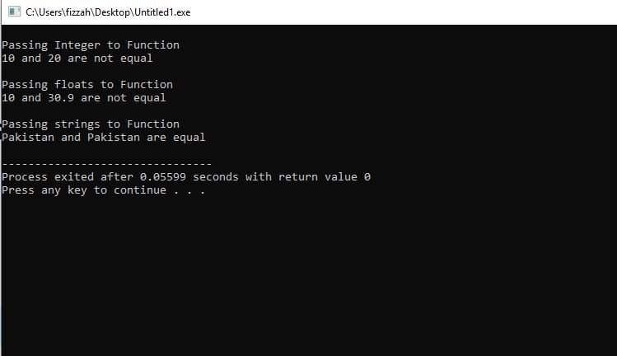
Solution
#include<iostream>
#include<string>
using namespace std;
class temp ()
{
public:
template <typename T> //Template
bool compare(T first, T second) //Function to compare two values of any type.
{
if(first==second) //if the first value is equal to second value
{
return true; //Then it return the true
}
else
{
return false; //if values are not equal it returns false
}
}
};
int main()
{
temp t1,t2,t3,t4; //Object creation of type temp
bool r1,r2,r3,r4;
int a=10, b=20; //variables of integer type.
cout<<endl<<"Passing Integer to Function"<<endl;
r1=t1.compare(a,b); //Calling the compare function with two integer variables.
if(r1==true) //if the function returns true it will print the given cout statement.
{
cout<<a<<" and "<<b<<" are equal"<<endl;
}
else //if the function returns false it will print the given cout statement.
{
cout<<a<<" and "<<b<<" are not equal" <<endl;
}
float c=10.0, d=30.9; //variables of Float type.
cout<<endl<<"Passing floats to Function"<<endl;
r3=t3.compare(c, d); //Calling the compare function with two float variables.
if(r3==true) //if the function returns true it will print the given cout statement.
{
cout<<c<<" and "<<d<<" are equal"<<endl;
}
else //if the function returns false it will print the given cout statement.
{
cout<<c<<" and "<<d<<" are not equal"<<endl;
}
//variables of string type.
string str1="Pakistan";
string str2="Pakistan";
cout<<endl<<"Passing strings to Function"<<endl;
r2=t2.compare(str1, str2); //Calling the compare function with two string variables.
if(r2==true) //if the function returns true it will print the given cout statement.
{
cout<<str1<<" and "<<str2<<" are equal" <<endl;
}
else //if the function returns false it will print the given cout statement.
{
cout<<str1<<" and "<<str2<<" are not equal" <<endl;
}

system("pause");
return 0;
}
Lab 12
Problem Statement
Write C++ code for the following template readData and Subtract classes.
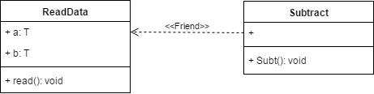
Subtract class is friend of ReadData class and can access the private data members of the Subtract class.
read() method of Subtract class is taking input from user for both data members.
In Subt() function create two objects of ReadData for int and float and perform subtraction on the data for both objects and print the result for each datatype.
Sequence Diagram
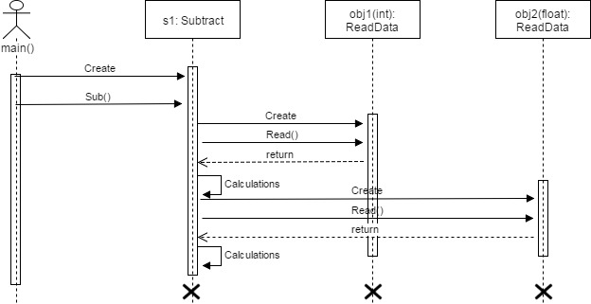
Sample Output
After running your program, the following output screen should display
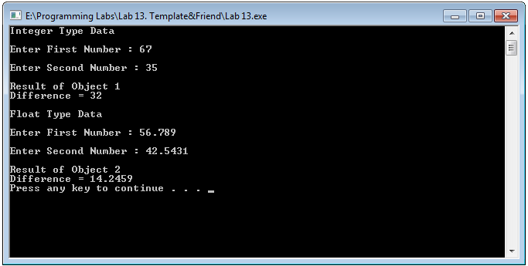
Solution:
#include<iostream>
#include<conio.h>
using namespace std;
template <class T> //Template Class
class readData
{
T a; //private variable “a” of T type.
T b; //private variable “b” of T type.
public:
friend class Subtract; //class Subtract is friend of class readData which means class Subtract can access the private data members of class readData without any error.
void read() //Read function to take input from the user
{
cout<<"\nEnter First Number : ";
cin>>a;
cout<<"\nEnter Second Number : ";
cin>>b;
}
};
class Subtract
{
public:
void Sub()
{
readData<int> obj1; //int type object
readData<float> obj2; //float type object

cout<<"Integer Type Data"<<endl;;
obj1.read(); //Accessing the read function of readData class
cout<<"\nResult of Object 1"<<endl;
cout<<"Difference = "<<obj1.a-obj1.b<<endl; //Subtraction of two int values
cout<<"\nFloat Type Data"<<endl;
obj2.read(); //Accessing the read function of readData class
cout<<"\nResult of Object 2"<<endl;
cout<<"Difference = "<<obj2.a-obj2.b<<endl; //Subtraction of two float values

}
};

int main()
{

Subtract s1; //object of class Subtract
s1.Sub(); //calling sub method of class Subtract
system("pause");
return 0;
}
Lab 13
Problem Statement
Write a program which should contain an integer Vector to store elements like:
vector<int> sampleVector;
and an Iterator to access elements like
vector<int>::iterator sampleIterator;
The program should store 5 elements 10, 20, 30, 40, 50 using push_back() and then show these elements on screen (Iterator will be used to access Vector elements).
Sample Output
After running your program, the following output screen should display
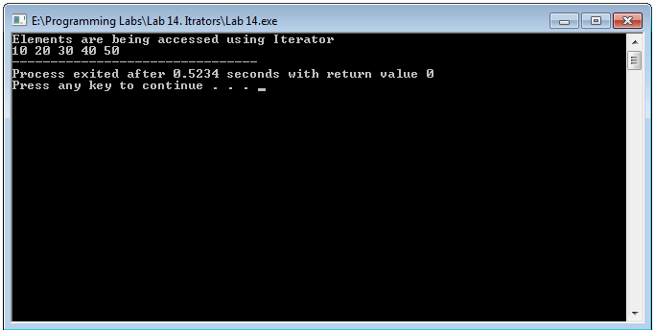
Solution
#include <iostream>
#include <vector> //Include the vector library
using namespace std;
int main()
{
vector<int> sampleVector; // a vector of integer type and name of vector is sampleVector
//push some integer values in the vector using push_back command.
sampleVector.push_back(10);
sampleVector.push_back(20);
sampleVector.push_back(30);
sampleVector.push_back(40);
sampleVector.push_back(50);
cout<<"Elements are being accessed using iterator "<<endl;
vector<int>::iterator sampleIterator; //declare an iterator to a vector of integer to access its elements
// now start at from the beginning keep iterating over the element till you reach the end of vector.
for(sampleIterator = sampleVector.begin(); sampleIterator != sampleVector.end(); sampleIterator++ )
{
cout<< *sampleIterator <<" "; //prints the elements of vector
}
}

Lab 14
Part 1:
Problem Statement
Write a program which should contain an integer set to store elements and an Iterator to access elements.
The program should store 5 elements 1,2,2,3,3 using insert() and then show the size of set before insertion and after insertion.
Sample Output
After running your program, the following output screen should display
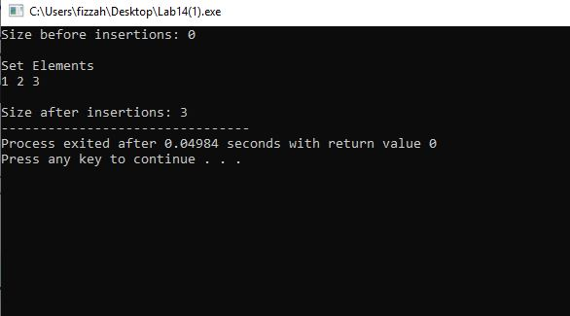

#include <iostream>
#include <set> //Include the set library
using namespace std;
int main()
{
set<int> sampleset; // a set of integer type and name of set is sampleset
cout << "Size before insertions: " << sampleset.size() << endl; //insert the size of set before insertion
//insert the elements in the set
sampleset.insert( 1 );
sampleset.insert( 2 );
sampleset.insert( 2 );
sampleset.insert( 3 );
sampleset.insert( 3 );
cout<<endl<<"Set Elements"<<endl;
//declare an iterator to a set of integers to access its elements
// now start at from the beginning keep iterating over the element till you reach the end of set.
set<int>::iterator si;
for(si = sampleset.begin(); si != sampleset.end(); si++ )
{
cout<< *si <<" "; //prints the elements of set
}
cout <<endl<<endl<< "Size after insertions: "<< sampleset.size(); //prints the size of set after insertion
}
Part 2:
Problem Statement
Write a program which should contain an integer multiset to store elements and an Iterator to access elements.
The program should store 5 elements 1,2,2,3,3 using insert() and then show the size of multiset before insertion and after insertion.
Sample Output
After running your program, the following output screen should display
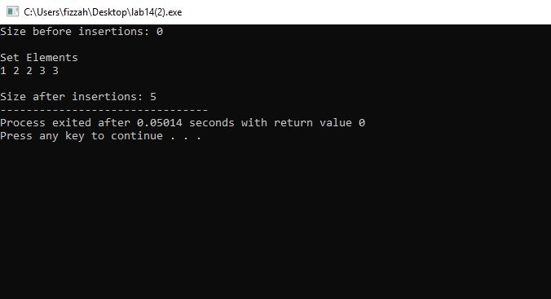

Solution
#include <iostream>
#include <set> //Include the set library
using namespace std;
int main()
{
multiset<int> samplemultiset; //a multiset of integer type and name of set is samplemultiset
//insert the size of multiset before insertion
cout << "Size before insertions: " << samplemultiset.size() << endl;
//insert the elements in the multiset
samplemultiset.insert( 1 );
samplemultiset.insert( 2 );
samplemultiset.insert( 2 );
samplemultiset.insert( 3 );
samplemultiset.insert( 3 );
cout<<endl<<"Set Elements"<<endl;
//declare an iterator to a multiset of integers to access its elements
// now start at from the beginning keep iterating over the element till you reach the end of multiset.
multiset<int>::iterator si;
for(si = samplemultiset.begin(); si != samplemultiset.end(); si++ )
{
cout<< *si <<" "; //prints the elements of multiset
}
//prints the size of multiset after insertion
cout <<endl<<endl<< "Size after insertions: "<< samplemultiset.size();
}
Lab 15
Part 1:
Problem Statement
Write a C++ program to divide the two number and it should throw the exception if number is divided by 0.
Sample Output
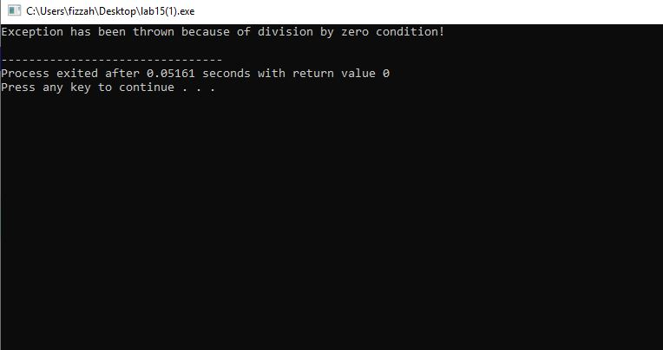
Solution
#include<iostream>
using namespace std;
double division(int a, int b) { //Defining the function division
if( b == 0 ) { //handling of division by zero
throw "Exception has been thrown because of division by zero condition!";
}
return (a/b); //return the result of division
}
int main () {
//storing 50 in numerator and 0 in denominator
int x = 50;
int y = 0;
double z = 0;
//Exception handling begins here.
try {
z = division(x, y); //calls the division function
cout << z << endl;
} catch (const char* msg) {
// we are raising an exception of type const char*, so while catching this exception, we have to use const char* in catch block.
cout << msg << endl;
}
return 0;
}
Part 2:
Problem Statement
Write a C++ program to create a vector named vec to store integer data. The program should throw exception when try to access the third element of vector vec.
Sample Output
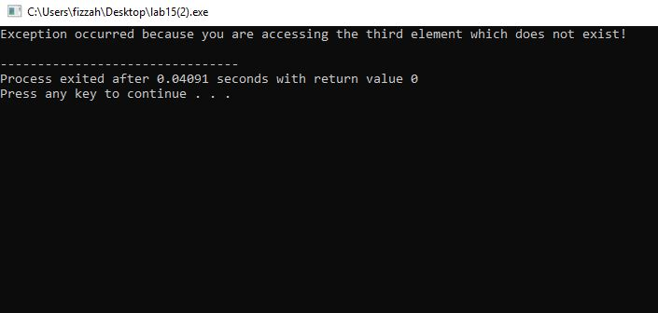
Solution
#include<iostream>
#include <vector> //Include the vector library
using namespace std;
int main()
{
vector<int> vec; //a vector of integer type and name of vector is vec
//push some integer values in the vector using push_back command.
vec.push_back(0);
vec.push_back(1);
//access the third element which does not exist
Try
{
vec.at(2); //access the third element
}
catch (exception& ex) //Exception will be catches here
{
cout<<"Exception occurred because you are accessing the third element which does not exist!"<<endl;
}
return 0;
}

